Practicals

1. To install and setup HTML based bootstrap framework and to deploy basic HTML element using Bootstrap CSS.
2. To understand and deploy the multicolumn grid layout of Bootstrap.
3. To deploy different types of buttons, progress bars, modals and navigation bars using Bootstrap.
4. To install and setup the CodeIgniter Framework and to understand its MVC architecture.
5. To construct a simple login page using Codelgniter Framework by changing necessary configuration and other files.
6. To perform unit testing on the login module constructed using Codelgniter
7. To install and setup the AngularJS Framework and to deploy dynamic routing based approach
8. To impliment AngularJS Directive based approach.
9. To perform debugging and testing of AngularJS module.
10. To create and setup Git repository on Bitbucket using SSH
11. To push all the practical performed to Bitbucket repository.
12. To perform push clone and patch operation to Bitbucket repository.
13. Mini Project: Student h. to do a project assigned from course contents in a group of two or three student. The group of students must submit a project report of 8 to 10 pages (approximately) and the team will have to demonstrate as well as have to give a

**Practical 1: To install and setup HTML based bootstrap framework and to deploy basic HTML element using Bootstrap CSS.**

What is Bootstrap?

1. Bootstrap is a free front-end framework for faster and easier web development
2. Bootstrap includes HTML and CSS based design templates for typography, forms, buttons, tables, navigation, modals, image carousels and many other, as well as optional JavaScript plugins
3. Bootstrap also gives you the ability to easily create responsive designs

**Installation steps and setup of bootstrap:-**

1. Download the bootstrap from its official website.

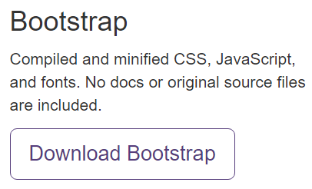

1. Unzip the bootstrap file which you have downloaded.

C:\Users\Mohit\Desktop\project screenshot\b1.PNG

1. Now create an index.html file in the bootstrap root folder.

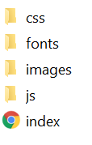

1. To use the bootstrap component first we have to do the linking of css and javascript in the index.html file

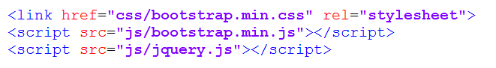

---------------------------------------Index.html-------------------------------------------

<!DOCTYPE html>

<html lang="en">

<head>

<title>Bootstrap 101 Template</title>

<link href="css/bootstrap.min.css" rel="stylesheet">

<script src="js/bootstrap.min.js"></script>

<script src="js/jquery.js"></script>

</head>

<body>

<ul class="nav nav-tabs">

<li role="presentation" class="active"><a href="#">Home</a></li>

<li role="presentation"><a href="#">Profile</a></li>

<li role="presentation"><a href="#">Messages</a></li>

</ul>

<div class="jumbotron">

<h1>Practical-1</h1>

</div>

<p><a class="btn btn-primary btn-lg" href="#" role="button">Learn more</a></p>

<div class="row">

<div class="col-xs-6 col-md-3">

<a href="#" class="thumbnail">

<img src="images/a.png" alt="...">

</a>

</div>

<div class="col-xs-6 col-md-3">

<a href="#" class="thumbnail">

<img src="images/a.png" alt="...">

</a>

</div>

<div class="col-xs-6 col-md-3">

<a href="#" class="thumbnail">

<img src="images/a.png" alt="...">

</a>

</div>

<div class="col-xs-6 col-md-3">

<a href="#" class="thumbnail">

<img src="images/a.png" alt="...">

</a>

</div>

</div>

</div>

</body>

</html>

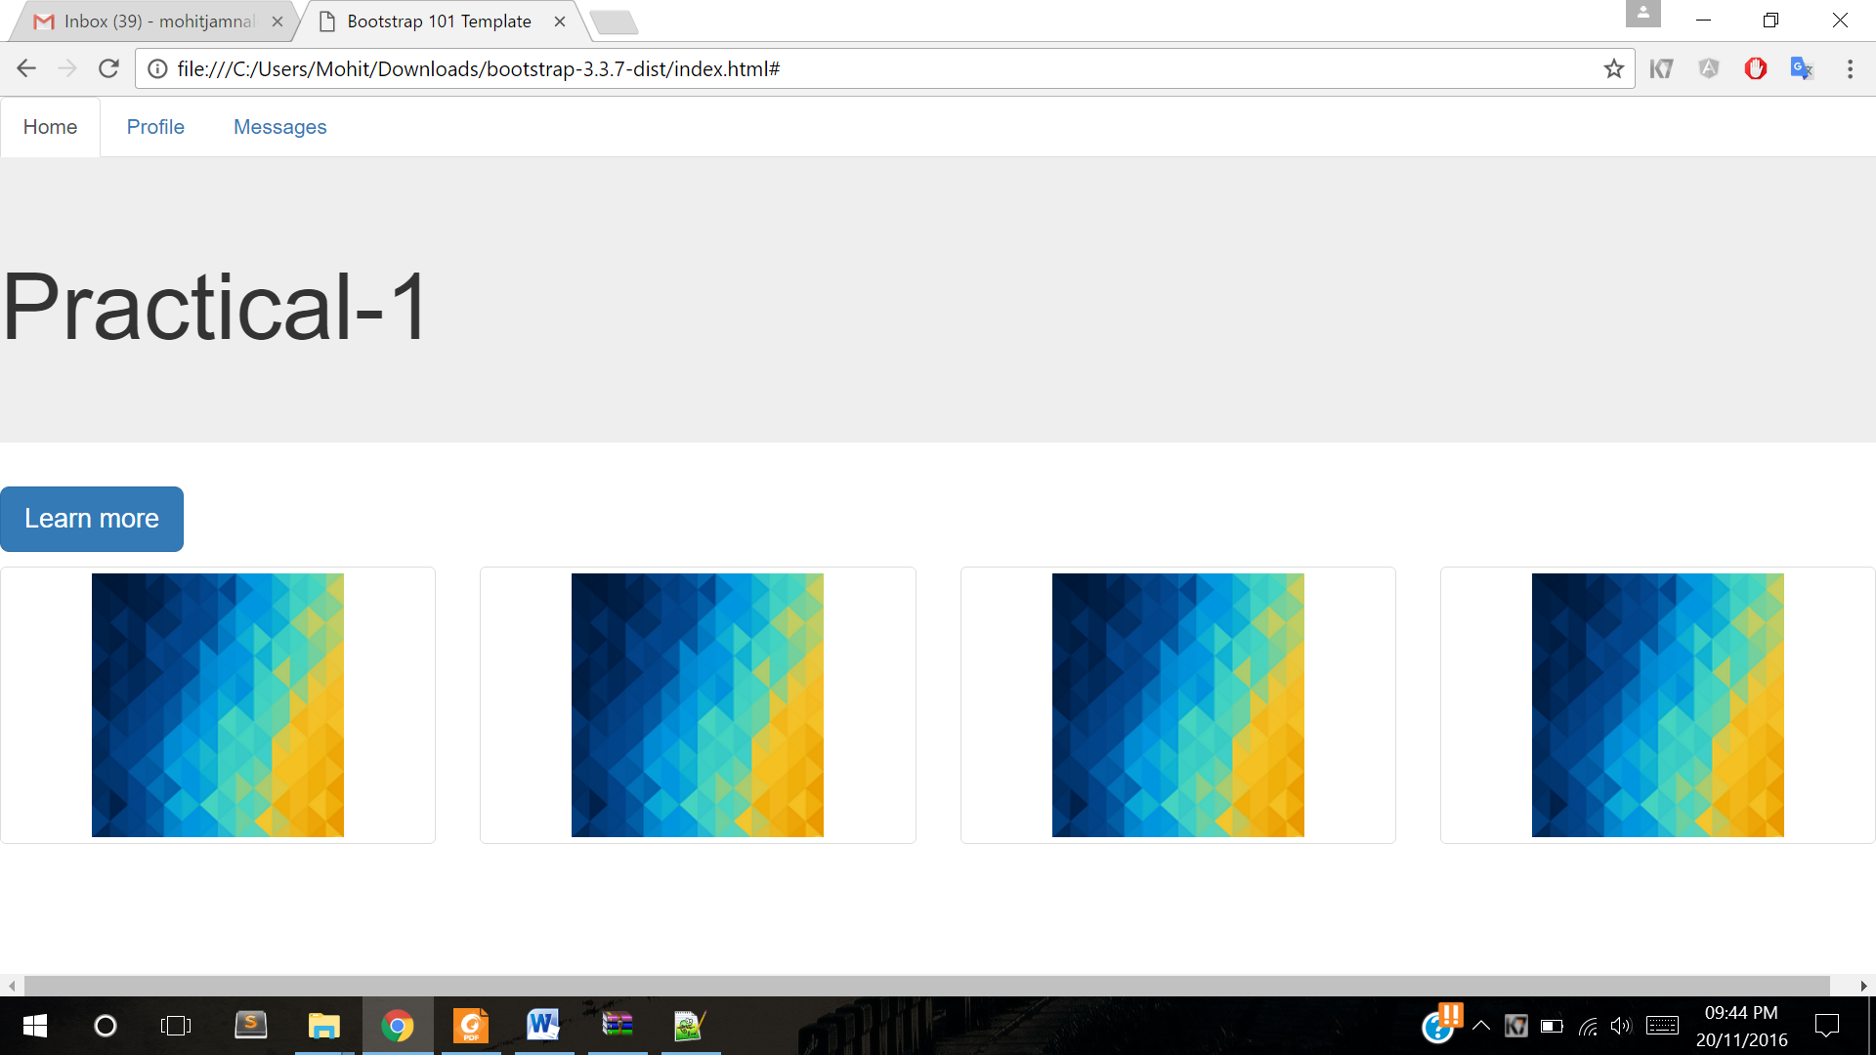

**Practical 2: To understand and deploy the multicolumn grid layout of Bootstrap.**

**Bootstrap Grid System**

Bootstrap's grid system allows up to 12 columns across the page.

If you do not want to use all 12 columns individually, you can group the columns together to create wider columns:

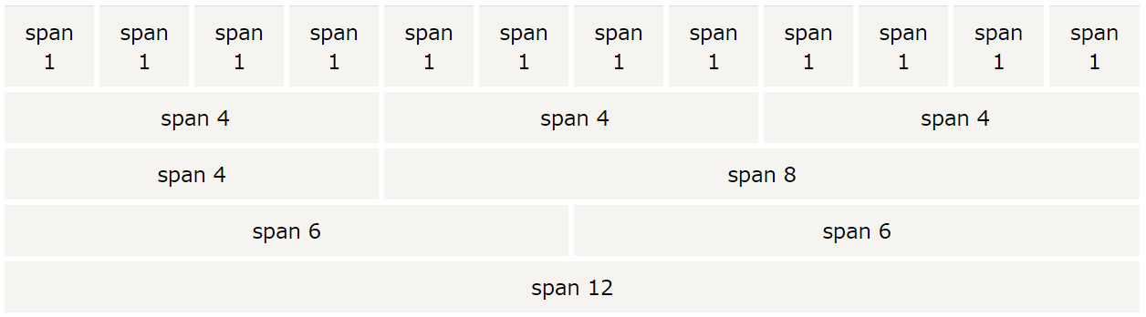

Bootstrap's grid system is responsive, and the columns will re-arrange automatically depending 1on the screen size.

**Grid Classes**

The Bootstrap grid system has four classes:

* xs (for phones)
* sm (for tablets)
* md (for desktops)
* lg (for larger desktops)

The classes above can be combined to create more dynamic and flexible layouts.

Example:-

<div class="row">  
  <div class="col-sm-4">.col-sm-4</div>  
  <div class="col-sm-4">.col-sm-4</div>  
  <div class="col-sm-4">.col-sm-4</div>  
</div>

Output:-



**Practical 3: To deploy different types of buttons, progress bars, modals and navigation bars using Bootstrap.**

**(I) Buttons:-**

Bootstrap provides seven styles of buttons:



To achieve the button styles above, Bootstrap has the following classes:

* .btn-default
* .btn-primary
* .btn-success
* .btn-info
* .btn-warning
* .btn-danger
* .btn-link

The following example shows the code for the different button styles:

* <!DOCTYPE html>
* <html lang="en">
* <head>
* <title>Bootstrap Example</title>
* <meta charset="utf-8">
* <meta name="viewport" content="width=device-width, initial-scale=1">
* <link rel="stylesheet" href=" css/bootstrap.min.css">
* <script src="jquery.min.js"></script>
* <script src="js/bootstrap.min.js"></script>
* </head>
* <body>
* <div class="container">
* <h2>Button Styles</h2>
* <button type="button" class="btn btn-default">Default</button>
* <button type="button" class="btn btn-primary">Primary</button>
* <button type="button" class="btn btn-success">Success</button>
* <button type="button" class="btn btn-info">Info</button>
* <button type="button" class="btn btn-warning">Warning</button>
* <button type="button" class="btn btn-danger">Danger</button>
* <button type="button" class="btn btn-link">Link</button>
* </div>
* </body>
* </html>

Output:- 

## Button Sizes

Bootstrap provides four button sizes:



The classes that define the different sizes are:

* .btn-lg
* .btn-md
* .btn-sm
* .btn-xs

**(II)Progress bars:-**

A progress bar can be used to show a user how far along he/she is in a process.

Bootstrap provides several types of progress bars.

**A default progress bar in Bootstrap looks like this:**



**Code:-**

* <!DOCTYPE html>
* <html lang="en">
* <head>
* <title>Bootstrap Example</title>
* <meta charset="utf-8">
* <meta name="viewport" content="width=device-width, initial-scale=1">
* <link rel="stylesheet" href="https://maxcdn.bootstrapcdn.com/bootstrap/3.3.7/css/bootstrap.min.css">
* <script src="https://ajax.googleapis.com/ajax/libs/jquery/1.12.4/jquery.min.js"></script>
* <script src="https://maxcdn.bootstrapcdn.com/bootstrap/3.3.7/js/bootstrap.min.js"></script>
* </head>
* <body>
* <div class="container">
* <h2>Basic Progress Bar</h2>
* <div class="progress">
* <div class="progress-bar" role="progressbar" aria-valuenow="70" aria-valuemin="0" aria-valuemax="100" style="width:70%">
* <span class="sr-only">70% Complete</span>
* </div>
* </div>
* </div>
* </body>
* </html>

## Progress Bar with Label

A progress bar with a label looks like this:

## Coloured Progress Bars

Contextual classes are used to provide "meaning through colors".

The contextual classes that can be used with progress bars are:

* .progress-bar-success
* .progress-bar-info
* .progress-bar-warning
* .progress-bar-danger

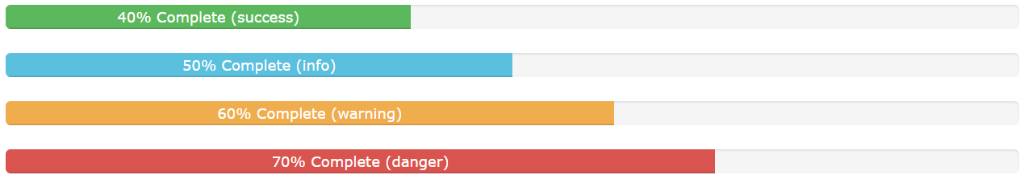

**Code:-**

* <!DOCTYPE html>
* <html lang="en">
* <head>
* <title>Bootstrap Example</title>
* <meta charset="utf-8">
* <meta name="viewport" content="width=device-width, initial-scale=1">
* <link rel="stylesheet" href="https://maxcdn.bootstrapcdn.com/bootstrap/3.3.7/css/bootstrap.min.css">
* <script src="https://ajax.googleapis.com/ajax/libs/jquery/1.12.4/jquery.min.js"></script>
* <script src="https://maxcdn.bootstrapcdn.com/bootstrap/3.3.7/js/bootstrap.min.js"></script>
* </head>
* <body>
* <div class="container">
* <h2>Colored Progress Bars</h2>
* <p>The contextual classes colors the progress bars:</p>
* <div class="progress">
* <div class="progress-bar progress-bar-success" role="progressbar" aria-valuenow="40" aria-valuemin="0" aria-valuemax="100" style="width:40%">
* 40% Complete (success)
* </div>
* </div>
* <div class="progress">
* <div class="progress-bar progress-bar-info" role="progressbar" aria-valuenow="50" aria-valuemin="0" aria-valuemax="100" style="width:50%">
* 50% Complete (info)
* </div>
* </div>
* <div class="progress">
* <div class="progress-bar progress-bar-warning" role="progressbar" aria-valuenow="60" aria-valuemin="0" aria-valuemax="100" style="width:60%">
* 60% Complete (warning)
* </div>
* </div>
* <div class="progress">
* <div class="progress-bar progress-bar-danger" role="progressbar" aria-valuenow="70" aria-valuemin="0" aria-valuemax="100" style="width:70%">
* 70% Complete (danger)
* </div>
* </div>
* </div>
* </body>
* </html>

**(III)Modals:-**

The Modal plugin is a dialog box/popup window that is displayed on top of the current page:

**Code:-**

* <!DOCTYPE html>
* <html lang="en">
* <head>
* <title>Bootstrap Example</title>
* <meta charset="utf-8">
* <meta name="viewport" content="width=device-width, initial-scale=1">
* <link rel="stylesheet" href="https://maxcdn.bootstrapcdn.com/bootstrap/3.3.7/css/bootstrap.min.css">
* <script src="https://ajax.googleapis.com/ajax/libs/jquery/1.12.4/jquery.min.js"></script>
* <script src="https://maxcdn.bootstrapcdn.com/bootstrap/3.3.7/js/bootstrap.min.js"></script>
* </head>
* <body>
* <div class="container">
* <h2>Modal Example</h2>
* <!-- Trigger the modal with a button -->
* <button type="button" class="btn btn-info btn-lg" data-toggle="modal" data-target="#myModal">Open Modal</button>
* <!-- Modal -->
* <div class="modal fade" id="myModal" role="dialog">
* <div class="modal-dialog">
* <!-- Modal content-->
* <div class="modal-content">
* <div class="modal-header">
* <button type="button" class="close" data-dismiss="modal">&times;</button>
* <h4 class="modal-title">Modal Header</h4>
* </div>
* <div class="modal-body">
* <p>Some text in the modal.</p>
* </div>
* <div class="modal-footer">
* <button type="button" class="btn btn-default" data-dismiss="modal">Close</button>
* </div>
* </div>
* </div>
* </div>
* </div>
* </body>
* </html>

**Output:-**

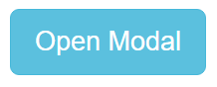

**(IV)Navigation Bars:-**

A navigation bar is a navigation header that is placed at the top of the page:

With Bootstrap, a navigation bar can extend or collapse, depending on the screen size.

A standard navigation bar is created with <nav class="navbar navbar-default">.

**Navigation Bar Classes:-**

.navbar-default

.navbar-inverse

.navbar-fixed-top

.navbar-fixed-bottom

.navbar-right

Code:-

* <!DOCTYPE html>
* <html lang="en">
* <head>
* <title>Bootstrap Case</title>
* <meta charset="utf-8">
* <meta name="viewport" content="width=device-width, initial-scale=1">
* <link rel="stylesheet" href="https://maxcdn.bootstrapcdn.com/bootstrap/3.3.7/css/bootstrap.min.css">
* <script src="https://ajax.googleapis.com/ajax/libs/jquery/1.12.4/jquery.min.js"></script>
* <script src="https://maxcdn.bootstrapcdn.com/bootstrap/3.3.7/js/bootstrap.min.js"></script>
* </head>
* <body>
* <nav class="navbar navbar-default">
* <div class="container-fluid">
* <div class="navbar-header">
* <a class="navbar-brand" href="#">WebSiteName</a>
* </div>
* <ul class="nav navbar-nav">
* <li class="active"><a href="#">Home</a></li>
* <li><a href="#">Page 1</a></li>
* <li><a href="#">Page 2</a></li>
* <li><a href="#">Page 3</a></li>
* </ul>
* </div>
* </nav>
* <div class="container">
* <h3>Basic Navbar Example</h3>
* <p>A navigation bar is a navigation header that is placed at the top of the page.</p>
* </div>
* </body>
* </html>

**Output:-**

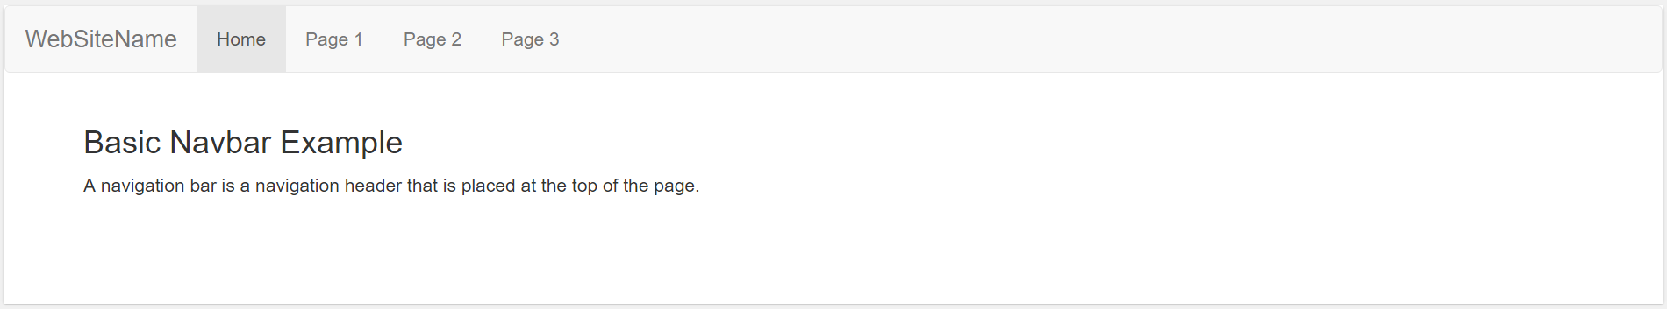

**Practical 4:-To install and setup the CodeIgniter Framework and to understand its MVC architecture.**

**CodeIgniter** is an Application Development Framework - a toolkit - for people who build web sites using PHP. Its goal is to enable you to develop projects much faster than you could if you were writing code from scratch, by providing a rich set of libraries for commonly needed tasks, as well as a simple interface and logical structure to access these libraries. CodeIgniter lets you creatively focus on your project by minimizing the amount of code needed for a given task.

Steps to install CodeIgniter:-

1. Unzip the package.



1. Upload the CodeIgniter folders and files to your server. Normally the index.php file will be at your root.

C:\Users\Mohit\AppData\Local\Microsoft\Windows\INetCache\Content.Word\1.png

1. Open the application/config/config.php file with a text editor and set your base URL. If you intend to use encryption or sessions, set your encryption key.

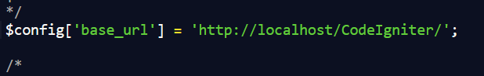

1. If you intend to use a database, open the application/config/database.php file with a text editor and set your database settings.

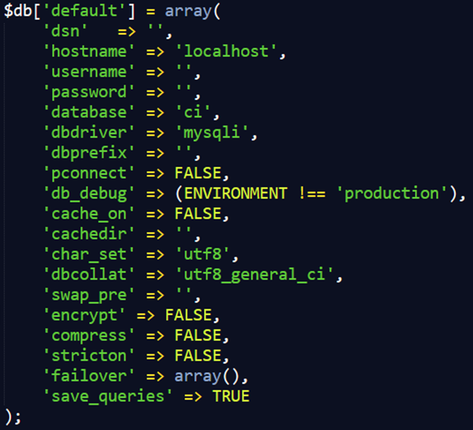

**MVC:-**

MVC (Model-View-Controller) is a software design pattern built around the interconnection of three main  
component types.

The three component are models, views, and controllers.

The model is where all the business logic of an application is kept

If the application should access information in a database, the code to do that would be kept in the model.

The view is where all of the user interface elements of our application are kept.

The controller is the component that connects models and views together.

Note- view is our frontend, model is our backend, and controller connects view and model

Controllers are the first point of entry among the 3 components, because the request  
is first sends to a controller, which will then initiate the models and views required to fulfill a request to the  
application.

Controller-communication between view and model

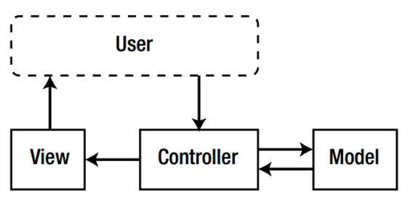

**Popular MVC Frameworks**

CodeIgniter

Zend Framework

Cake php

**MVC Pattern** stands for Model-View-Controller Pattern. This pattern is used to separate application's concerns.

* **Model** - Model represents an object or JAVA POJO carrying data. It can also have logic to update controller if its data changes.
* **View** - View represents the visualization of the data that model contains.
* **Controller** - Controller acts on both model and view. It controls the data flow into model object and updates the view whenever data changes. It keeps view and model separate.

**Practical 5:-To construct a simple login page using Codelgniter Framework by changing necessary configuration and other files.**

**Config:-**

--------------------------------------database.php--------------------------------------

$db['default'] = array(

'dsn' => '',

'hostname' => 'localhost',

'username' => 'root',

'password' => 'mohit',

'database' => 'ci',

'dbdriver' => 'mysqli',

'dbprefix' => '',

'pconnect' => FALSE,

'db_debug' => (ENVIRONMENT !== 'production'),

'cache_on' => FALSE,

'cachedir' => '',

'char_set' => 'utf8',

'dbcollat' => 'utf8_general_ci',

'swap_pre' => '',

'encrypt' => FALSE,

'compress' => FALSE,

'stricton' => FALSE,

'failover' => array(),

'save_queries' => TRUE

);

**Controller:-**

--------------------------------------login.php--------------------------------------

* <?php
* defined('BASEPATH') OR exit('No direct script access allowed');
* class Login extends CI_Controller {
* public function index()
* {
* $this->form_validation->set_rules('username','username','trim|required');
* $this->form_validation->set_rules('password','password','trim|required|callback_basisdata_cek');
* if($this->form_validation->run()==false){
* $this->load->view('login_view');
* }else{
* redirect(base_url('index.php/home'), 'refresh');
* }
* }
* function basisdata_cek($password){
* $username = $this->input->post('username');
* $result = $this->login->login($username,$password);
* if($result){
* $sess_array = array();
* foreach ($result as $row){
* $sess_array = $arrayName = array('id' => $row->id,'username' => $row->username,'fullname' => $row->fullname);
* $this->session->set_userdata('logged_in',$sess_array);
* }
* return true;
* }else{
* $this->form_validation->set_message('basisdata_cek','Invalid username or password');
* return false;
* }
* }
* public function register(){
* if($this->input->post('daftar')){
* $this->login->register();
* redirect('login');
* }else{
* $this->load->view('register_view');
* }
* }
* }

--------------------------------------home.php--------------------------------------

<?php

defined('BASEPATH') OR exit('No direct script access allowed');

class Home extends CI_Controller {

public function index()

{

if($this->session->userdata('logged_in')){

$session_data = $this->session->userdata('logged_in');

$data['id'] = $session_data['id'];

$data['fullname'] = $session_data['fullname'];

$data['username'] = $session_data['username'];

$this->load->view('home_view', $data);

}else{

redirect('login','refresh');

}

}

public function logout()

{

$this->session->unset_userdata('logged_in');

$this->session->sess_destroy();

redirect(site_url('login'),'refresh');

}

}

**Models:-**

--------------------------------------login_model.php--------------------------------------

<?php

defined('BASEPATH') OR exit('No direct script access allowed');

class Login_model extends CI_Model {

function login($username, $password){

$this->db->select('id,fullname,username,password');

$this->db->from('user');

$this->db->where('username', $username);

$this->db->where('password', md5($password));

$this->db->limit(1);

$query = $this->db->get();

if($query->num_rows()==1){

return $query->result();

}else{

return false;

}

}

function register(){

$fn = $this->input->post('fullname');

$un = $this->input->post('username');

$pw = md5( $this->input->post('password'));

$data = array(

'id' => '',

'fullname' => $fn,

'username' => $un,

'password' => $pw

);

$this->db->insert('user',$data);

}

}

**Views:-**

--------------------------------------login_view.php--------------------------------------

<!DOCTYPE html>

<html lang="en">

<head>

<meta charset="utf-8">

<meta http-equiv="X-UA-Compatible" content="IE=edge">

<meta name="viewport" content="width=device-width, initial-scale=1">

<!-- The above 3 meta tags *must* come first in the head; any other head content must come *after* these tags -->

<title>Login Area</title>

<!-- Bootstrap -->

<link href="<?php echo base_url('assets/css/bootstrap.min.css') ?>" rel="stylesheet">

<!-- HTML5 shim and Respond.js for IE8 support of HTML5 elements and media queries -->

<!-- WARNING: Respond.js doesn't work if you view the page via file:// -->

<!--[if lt IE 9]>

<script src="https://oss.maxcdn.com/html5shiv/3.7.3/html5shiv.min.js"></script>

<script src="https://oss.maxcdn.com/respond/1.4.2/respond.min.js"></script>

<![endif]-->

</head>

<body>

<div class="container" style="margin-top:100px;">

<div class="row">

<div class="col-md-4"></div>

<div class="col-md-4">

<div class="panel panel-default">

<div class="panel-body">

<?php

if(validation_errors()){

?>

<div class="alert alert-danger alert-dismissible" role="alert">

<button type="button" class="close" data-dismiss="alert" aria-label="Close"><span aria-hidden="true">&times;</span></button>

<strong><?php echo validation_errors(); ?></strong>

</div>

<?php

}

echo form_open('login','class="myclass"')

?>

<div class="form-group">

<?php

echo form_label('Username','username');

echo form_input('username','','class="form-control" id="username" placeholder="Name"')

?>

</div>

<div class="form-group">

<?php

echo form_label('Password','password');

echo form_password('password','','class="form-control" id="password" placeholder="Password"')

?>

</div>

<?php echo form_submit('login', 'Login', 'class="btn btn-primary"') ?>

<a href="<?php echo site_url('login/register') ?>" class="btn btn-link">Signup</a>

<?php echo form_close() ?>

</form>

</div>

</div>

<div>

</div>

<div class="col-md-4"></div>

</div>

</div>

<!-- jQuery (necessary for Bootstrap's JavaScript plugins) -->

<script src="<?php echo base_url('assets/js/jquery.min.js') ?>"></script>

<!-- Include all compiled plugins (below), or include individual files as needed -->

<script src="<?php echo base_url('assets/js/bootstrap.min.js') ?>"></script>

</body>

</html>

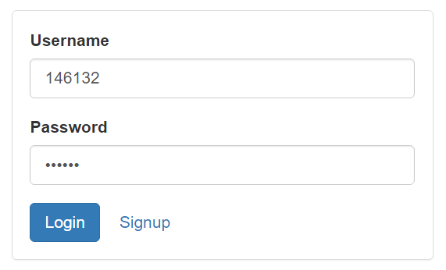

--------------------------------------Register_view.php--------------------------------------

<!DOCTYPE html>

<html lang="en">

<head>

<meta charset="utf-8">

<meta http-equiv="X-UA-Compatible" content="IE=edge">

<meta name="viewport" content="width=device-width, initial-scale=1">

<!-- The above 3 meta tags *must* come first in the head; any other head content must come *after* these tags -->

<title>Register Area</title>

<!-- Bootstrap -->

<link href="<?php echo base_url('assets/css/bootstrap.min.css') ?>" rel="stylesheet">

<!-- HTML5 shim and Respond.js for IE8 support of HTML5 elements and media queries -->

<!-- WARNING: Respond.js doesn't work if you view the page via file:// -->

<!--[if lt IE 9]>

<script src="https://oss.maxcdn.com/html5shiv/3.7.3/html5shiv.min.js"></script>

<script src="https://oss.maxcdn.com/respond/1.4.2/respond.min.js"></script>

<![endif]-->

</head>

<body>

<div class="container" style="margin-top:100px;">

<div class="row">

<div class="col-md-4"></div>

<div class="col-md-4">

<div class="panel panel-default">

<div class="panel-body">

<?php

if(validation_errors()){

?>

<div class="alert alert-danger alert-dismissible" role="alert">

<button type="button" class="close" data-dismiss="alert" aria-label="Close"><span aria-hidden="true">&times;</span></button>

<strong><?php echo validation_errors(); ?></strong>

</div>

<?php

}

echo form_open('login/register','class="myclass"')

?>

<div class="form-group">

<?php

echo form_label('Full Name','fullname');

echo form_input('fullname','','class="form-control" id="fullname" placeholder="Full Name"')

?>

</div>

<div class="form-group">

<?php

echo form_label('Username','username');

echo form_input('username','','class="form-control" id="username" placeholder="Name"')

?>

</div>

<div class="form-group">

<?php

echo form_label('Password','password');

echo form_password('password','','class="form-control" id="password" placeholder="Password"')

?>

</div>

<?php echo form_submit('daftar', 'Register', 'class="btn btn-primary"') ?>

<a href="<?php echo site_url('login') ?>" class="btn btn-link">Sign In </a>

<?php echo form_close() ?>

</form>

</div>

</div>

<div>

</div>

<div class="col-md-4"></div>

</div>

</div>

<!-- jQuery (necessary for Bootstrap's JavaScript plugins) -->

<script src="<?php echo base_url('assets/js/jquery.min.js') ?>"></script>

<!-- Include all compiled plugins (below), or include individual files as needed -->

<script src="<?php echo base_url('assets/js/bootstrap.min.js') ?>"></script>

</body>

</html>

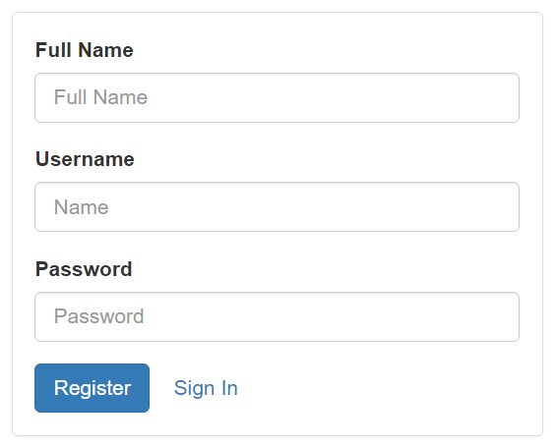

--------------------------------------home_view.php--------------------------------------

<!DOCTYPE html>

<html lang="en">

<head>

<meta charset="utf-8">

<meta http-equiv="X-UA-Compatible" content="IE=edge">

<meta name="viewport" content="width=device-width, initial-scale=1">

<!-- The above 3 meta tags *must* come first in the head; any other head content must come *after* these tags -->

<title>Administrator Area</title>

<!-- Bootstrap -->

<link href="<?php echo base_url('assets/css/bootstrap.min.css') ?>" rel="stylesheet">

<!-- HTML5 shim and Respond.js for IE8 support of HTML5 elements and media queries -->

<!-- WARNING: Respond.js doesn't work if you view the page via file:// -->

<!--[if lt IE 9]>

<script src="https://oss.maxcdn.com/html5shiv/3.7.3/html5shiv.min.js"></script>

<script src="https://oss.maxcdn.com/respond/1.4.2/respond.min.js"></script>

<![endif]-->

</head>

<body>

<!--**********NAV BAR STARTS********** -->

<nav class="navbar navbar-default navbar-static-top">

<div class="container-fluid">

<!-- Brand and toggle get grouped for better mobile display -->

<div class="navbar-header">

<button type="button" class="navbar-toggle collapsed" data-toggle="collapse" data-target="#bs-example-navbar-collapse-1" aria-expanded="false">

<span class="sr-only">Toggle navigation</span>

<span class="icon-bar"></span>

<span class="icon-bar"></span>

<span class="icon-bar"></span>

</button>

<a class="navbar-brand" href="#">Brand</a>

</div>

<!-- Collect the nav links, forms, and other content for toggling -->

<div class="collapse navbar-collapse" id="bs-example-navbar-collapse-1">

<ul class="nav navbar-nav">

<li class="active"><a href="#">Link <span class="sr-only">(current)</span></a></li>

<li><a href="#">Link</a></li>

<li class="dropdown">

<a href="#" class="dropdown-toggle" data-toggle="dropdown" role="button" aria-haspopup="true" aria-expanded="false">Dropdown <span class="caret"></span></a>

<ul class="dropdown-menu">

<li><a href="#">Action</a></li>

<li><a href="#">Another action</a></li>

<li><a href="#">Something else here</a></li>

<li role="separator" class="divider"></li>

<li><a href="#">Separated link</a></li>

<li role="separator" class="divider"></li>

<li><a href="#">One more separated link</a></li>

</ul>

</li>

</ul>

<form class="navbar-form navbar-left">

<div class="form-group">

<input type="text" class="form-control" placeholder="Search">

</div>

<button type="submit" class="btn btn-default">Submit</button>

</form>

<ul class="nav navbar-nav navbar-right">

<li><a href="#"><?php echo $fullname ?></a></li>

<li class="dropdown">

<a href="#" class="dropdown-toggle" data-toggle="dropdown" role="button" aria-haspopup="true" aria-expanded="false">Dropdown <span class="caret"></span></a>

<ul class="dropdown-menu">

<li><a href="#">Action</a></li>

<li><a href="#">Another action</a></li>

<li><a href="#">Something else here</a></li>

<li role="separator" class="divider"></li>

<li><a href="#">Separated link</a></li>

</ul>

</li>

</ul>

</div><!-- /.navbar-collapse -->

</div><!-- /.container-fluid -->

</nav>

<!-- **********NAV BAR ENDS**********-->

<div class="container" style="margin-top:20px;">

<div class="jumbotron">

<div class="row">

<div class="col-md-3">

<input type="text" class="form-control" placeholder="Username" aria-label="...">

</div><!-- /input-group -->

<div class="col-md-3">

<input type="text" class="form-control" placeholder="Mobile No." aria-label="...">

</div><!-- /input-group -->

</div><!-- /.col-lg-6 -->

<br>

<div class="row">

<div class="col-md-3">

<textarea rows="4" cols="50" class="form-control" placeholder="Address"></textarea>

</div><!-- /input-group -->

</div><!-- /.col-lg-6 -->

<br>

<div class="row">

<div class="col-md-3">

<input type="text" class="form-control" placeholder="E-mail" aria-label="...">

</div><!-- /input-group -->

</div><!-- /.col-lg-6 -->

<hr >

<div><h3>Carrer Objective</h3></div>

<div class="row">

<div class="col-md-3">

<textarea rows="4" cols="50" class="form-control" placeholder="...."></textarea>

</div><!-- /input-group -->

</div><!-- /.col-lg-6 -->

<div><h3>Work Experience</h3></div>

<div class="row">

<div class="col-md-3">

<input type="text" class="form-control" placeholder="...." aria-label="...">

</div><!-- /input-group -->

</div><!-- /.col-lg-6 -->

<div><h3>Speciliazation</h3></div>

<div class="row">

<div class="col-md-3">

<input type="text" class="form-control" placeholder="...." aria-label="...">

</div><!-- /input-group -->

</div><!-- /.col-lg-6 -->

<div><h3>Educational Qualification</h3></div>

<table class="table" >

<tr>

<td>Qualification</td>

<td>Institute</td>

<td>Board</td>

<td>Year</td>

<td>Marks</td>

</tr>

<tr>

<td> <input type="text" class="form-control" placeholder="" aria-label="..."></td>

<td><input type="text" class="form-control" placeholder="" aria-label="..."></td>

<td><input type="text" class="form-control" placeholder="" aria-label="..."></td>

<td><input type="text" class="form-control" placeholder="" aria-label="..."></td>

<td><input type="text" class="form-control" placeholder="" aria-label="..."></td>

</tr>

<tr>

<td> <input type="text" class="form-control" placeholder="" aria-label="..."></td>

<td><input type="text" class="form-control" placeholder="" aria-label="..."></td>

<td><input type="text" class="form-control" placeholder="" aria-label="..."></td>

<td><input type="text" class="form-control" placeholder="" aria-label="..."></td>

<td><input type="text" class="form-control" placeholder="" aria-label="..."></td>

</tr>

<tr>

<td> <input type="text" class="form-control" placeholder="" aria-label="..."></td>

<td><input type="text" class="form-control" placeholder="" aria-label="..."></td>

<td><input type="text" class="form-control" placeholder="" aria-label="..."></td>

<td><input type="text" class="form-control" placeholder="" aria-label="..."></td>

<td><input type="text" class="form-control" placeholder="" aria-label="..."></td>

</tr>

<tr>

<td> <input type="text" class="form-control" placeholder="" aria-label="..."></td>

<td><input type="text" class="form-control" placeholder="" aria-label="..."></td>

<td><input type="text" class="form-control" placeholder="" aria-label="..."></td>

<td><input type="text" class="form-control" placeholder="" aria-label="..."></td>

<td><input type="text" class="form-control" placeholder="" aria-label="..."></td>

</tr>

<tr>

<td> <input type="text" class="form-control" placeholder="" aria-label="..."></td>

<td><input type="text" class="form-control" placeholder="" aria-label="..."></td>

<td><input type="text" class="form-control" placeholder="" aria-label="..."></td>

<td><input type="text" class="form-control" placeholder="" aria-label="..."></td>

<td><input type="text" class="form-control" placeholder="" aria-label="..."></td>

</tr>

</table>

<div><h3>Training Undertaken</h3></div>

</div><!-- /.row -->

<p><a class="btn btn-primary btn-lg" href="" role="button">Generate PDF</a>&nbsp;&nbsp;&nbsp;<a class="btn btn-primary btn-lg" href="<?php echo site_url('home/logout') ?>" role="button">Logout</a></p>

</div>

</div>

<!-- jQuery (necessary for Bootstrap's JavaScript plugins) -->

<script src="<?php echo base_url('assets/js/jquery.js') ?>"></script>

<!-- Include all compiled plugins (below), or include individual files as needed -->

<script src="<?php echo base_url('assets/js/bootstrap.min.js') ?>"></script>

</body>

</html>

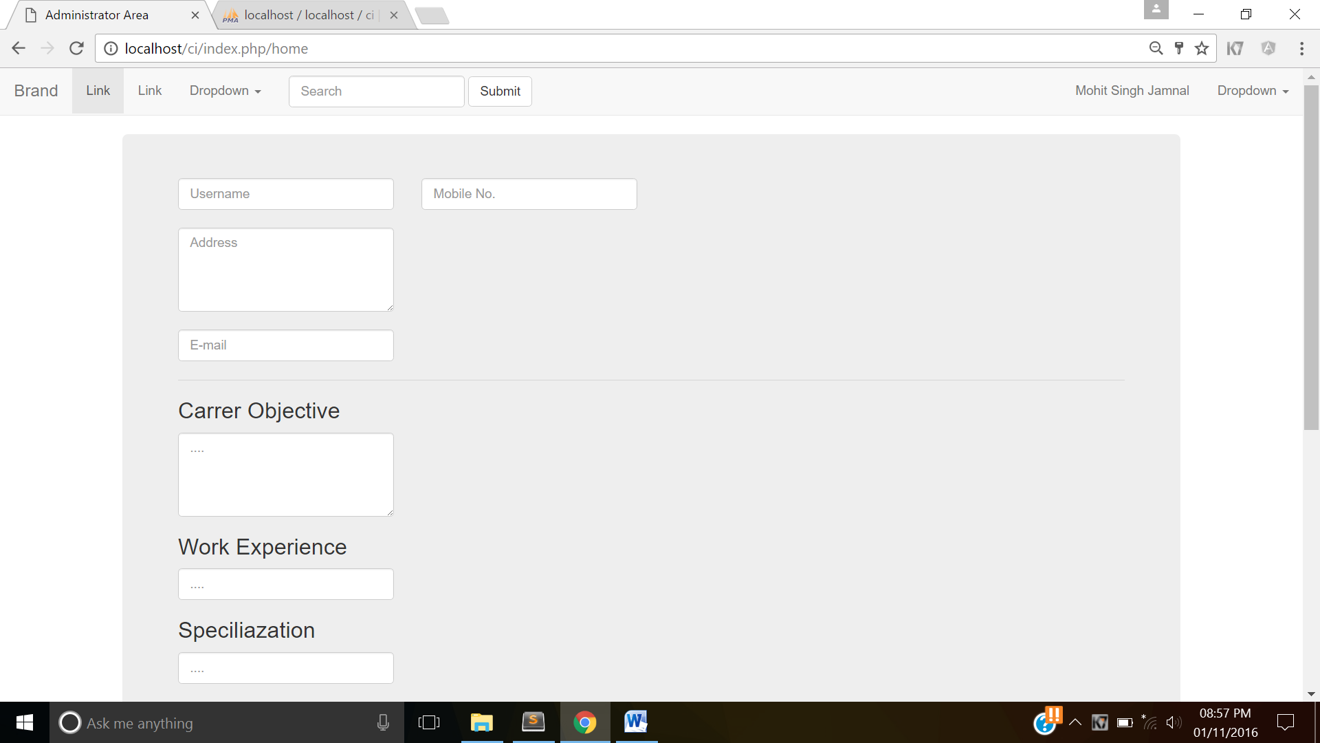

**Practical 6:-To perform unit testing on the login module constructed using Codelgniter.**

Unit testing is an approach to software development in which tests are written for each function in your application.

CodeIgniter’s Unit Test class is quite simple, consisting of an evaluation function and two result functions. It’s not intended to be a full-blown test suite but rather a simple mechanism to evaluate your code to determine if it is producing the correct data type and result.

**Practical 7:-**To install and setup the AngularJS Framework and to deploy dynamic routing based approach

**Practical 8:-**To impliment AngularJS Directive based approach.

**Practical 9:-**To perform debugging and testing of AngularJS module.

AngularJS is becoming **immensely popular** and **mainstream** which means that there is a lot of AngularJS code out there that is being tested

There are some online and ofﬂine tools available to debug and test responsive web applications.

**Batarang**

1. Batarang is the Chrome extension to debug the AngularJS application.
2. This extension is developed by the AngularJS team.
3. Using Batarang, we can debug:-
   1. models
   2. bindings
   3. dependencies
   4. scopes
   5. applications
4. Batarang also exposessome methods as APIs to be accessed by the developer console.

**Installing and confguring Batarang**

Batarang is a Chrome extension and is available in Chrome Web store. You can  
search for Batarang in Chrome Web store and install it.

**Practical 10:-**To create and setup Git repository on GitHub

Step1:- Login your account

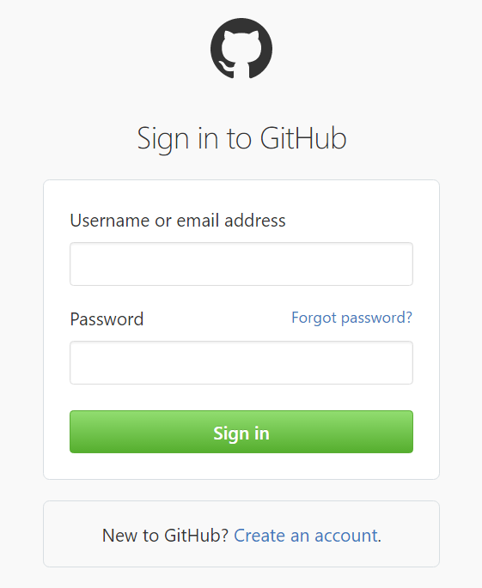

Step2:- Click on New repository

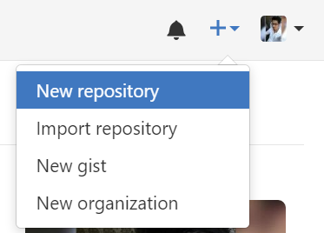

Step3:- Type Repository name

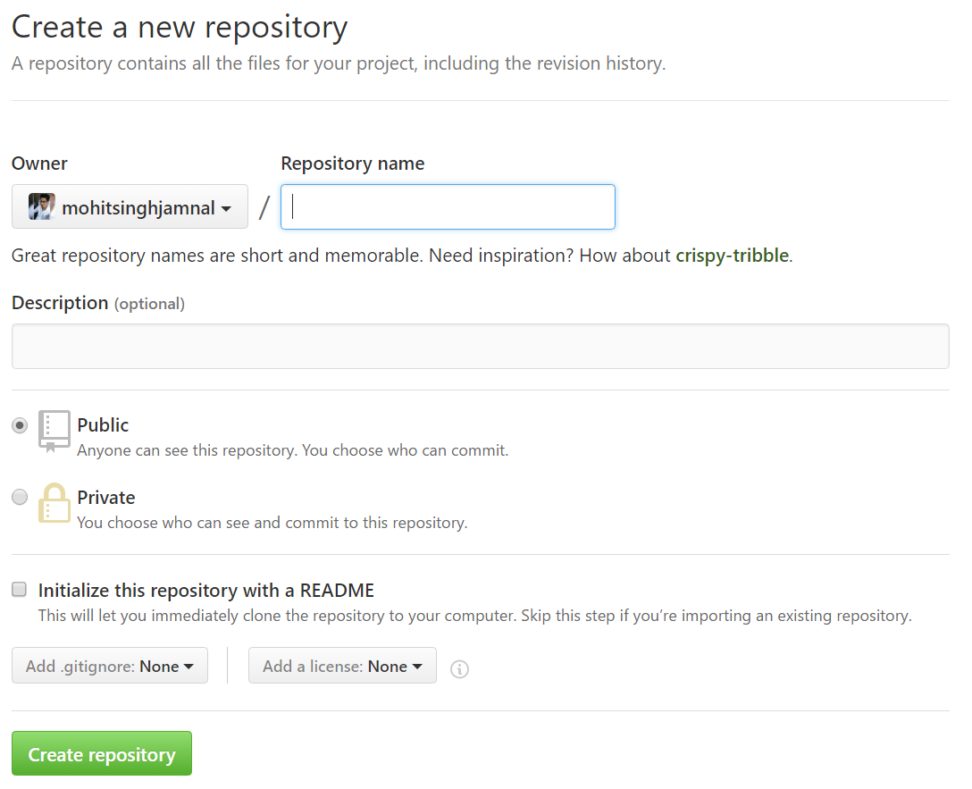

Step 5:- Click on Create repository

**Practical 11:-**To push all the practical performed to Bitbucket repository.

**Practical 12:-**To perform push clone and patch operation to Bitbucket repository.